General Information
Name or title of activity: | Campus Compass
Brief description (20 words): | Interactive tour on campus, where students have to find their way on the campus in small teams. Each team follows a predetermined route with several stations. At each station, teams have to solve a riddle or Multiple choice question related to university life. Each answer produces a character. At the end of the tour, each team has to construct a meaningful word using all characters. Only with the right answers, you can compose the final long word. The winning team will be randomly selected from all teams that succeeded in using all characters , and this winning team gets a prize.
Which discipline(s), field(s), or programme(s) does the activity relate to? | Discipline: all  Field: all  Programme: all
What type of integration does the activity aim to support:  (Titles from Codebook) | Academic Integration  Self-regulation  General structure of the semester  Quantity of work  Managing workloads/ different learning approaches.  Committing to the study  Processing learning content  Feeling prepared  Feeling competent  Social Integration  Establishing a first connection  Establishing a deeper connection  Practical Aspects of Student Life  Managing Institutional Communication  Campus Facilities  Managing Life  Balancing free time and academic life  Environmental Adaptation  Academic Freedom  Perceived Academic Support  Perceived Social Support  Sense of Belonging  Mental well-being  Disability
What type of intervention is it:  (From Literature Review) | Micro intervention  Course and Teaching Strategies  Gamification and Technology  Installing Learning Communities  Social Support and Mentoring  Summer School  Mindset  Orientation Program
Target audience: | New first year students
Number of students: | Teams of 6 students. Ideally, no more than 10 teams do the Campus Compass simultaneously
Objectives & Focus
What type of activity is it? | Interactive tour on campus
When does the activity take place? | During starter/orientation days
How long does the activity last? | Depending on the number of stations. We recommend a 2 hour tour

Participants & Implementation
Level of commitment of instructors to design and develop the intervention: | Low (1 day)  Medium (1 week)  High (1 month or greater)
Level of commitment of students: | Low (1 day)  Medium (1 week)  High (1 month or greater)
Timescale to complete intervention (how long the activity lasts): | 2 hours
Who is involved in delivering the activity? | Flexible, depending on how the stations are designed.  Student Societies/organisations/clubs (minimal)  Teaching staff (Optional – Additional staff)
Is the activity individual or group-based? | Individual Group  Small Groups of students
Is participation voluntary or mandatory? | Voluntary Mandatory
Is the activity intracurricular or extracurricular? | Intracurricular (with ECTS credits)  Extracurricular  Both
In what format is the activity delivered? | On campus (live)  Online  Blended  Asynchronous (e.g. self-paced module)  Other
Physical resources required (rooms, equipment, software, materials, prizes): | Interesting locations on campus, a script with outline of campus tour for each participating team, prize for the winning team
Human resources required? | Optional - if meeting staff is integrated as activity during campus compass
Financial resources required: | Prize for winning team
Online resources | /

Outline of Activity
Several interesting locations, called “stations” are selected on the campus, and noted with numbers on a campus map.
Small student teams follow the self-guided tour and solve the questions at each station.
At the end of the tour, they solve the riddle using the collected characters, and the winning team will get a prize.
The aim of the interactive tour is that student teams discover the campus by working together, and meanwhile get to know each other.

Detailed Plan
(Include a brief step-by-step breakdown, timeline, tasks, and roles.)
Designing the tour
- Select 8 to 10 locations on your campus that are essential for new students to get acquainted with.
- Compose a tour by connecting the different locations and denote the tour on a campus map (see example below).
- Design a written guideline for the students, consisting of a welcome, some interesting facts about the campus and at each location, a multiple choice question or riddle.
- Provide sufficient photos so that students will find each location
- Students get access to the question by scanning a QR code
Tip: to make the tour feasible for the big students groups, the stations should be mainly without personnel involved. However, you might add an activity where students will have to find the office of their tutor, and pay her or him a visit.
See example in Annex
Starting the tour
Student organizations compose the student teams by ordering student name lists at random, and calling out names until a team of 6 is composed.
Each team is sent out to follow the self-guided tour and solve the questions at each station.
To prevent queuing and crowding at stations, it is suggested to let consecutive teams start with a different number on the tour as first station.
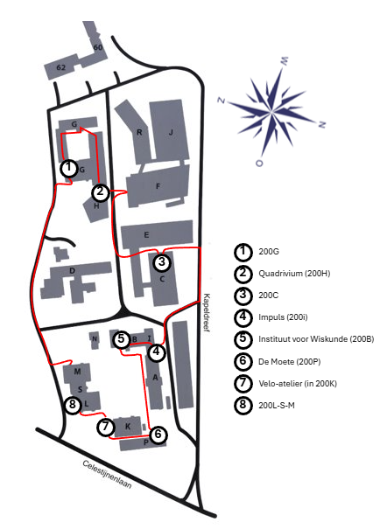
Ending the tour
To make sure that each team completes the tour, there should be an organized starters day activity scheduled after the tour. This will stimulate the teams to complete the tour and hand in their solution to the final question.
Tip: a suitable prize might be a food coupon for each team member, to be used in the student restaurant.
Evaluation & Impact
(How) is this activity evaluated?  - How (forms, questions, follow data…), with who (participants, organizers…), about what (reaching of goals, content, organizational aspect…)?  - What are the results?  - What do you do with the results? (Inform the next iteration, feedback for students, policy changes at University?) | - Students are surveyed with anonymous google form after the orientation program and questioned about their academic and social integration  - Results are used to optimise the tour for the next year
(How) is the effectiveness tracked?
- How?
- What are the results?
- What is the purpose of collecting the results, how will they be used?

Any further notes:

References or inspiration used to design intervention:
Add any papers which describe the intervention or which you used to inspire you
- Lize Vanderstraeten “Navigating change during the transition to higher education: Evidence on student well-being and orientation initiatives in economics and business education” PhD 2024
- Expedition The Nayer at Faculty of Engineering Technology KU Leuven
- Campus Kompas designed by Bert De Groef Faculty of Science at KU Leuven.

